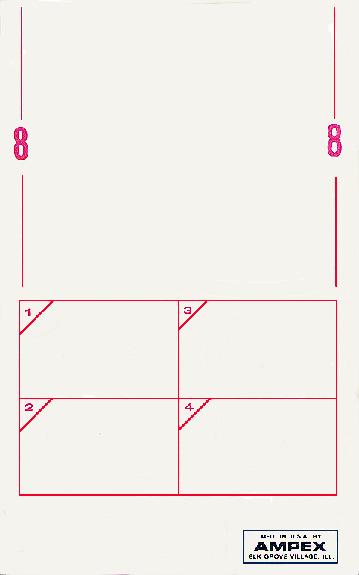

## red house

## midnight lightning

voodoo chile

**power to love**

**blue suede shoes**

### johnny b. goode

lover man

little wing

sgt. pepper’s lonely heart’s club band

**8st-5567 2 4**

**HENDRIX IN THE WEST**

# **JIMI HENDRIX**

reprise 8- track stereo

